NET731 Advanced Networking
Week 6 Practical: Cloud Security Review

Module  NET731 | Week  6 (10–16 April 2025) | Total Marks  10 Marks | NQF Level  7

Overview
In this practical, you will act as a cloud security analyst responsible for assessing and improving the security posture of an Azure-hosted environment. You will use Microsoft Defender for Cloud to surface real security gaps, apply targeted remediations, and document your findings and improvements in a structured GitHub repository.
This is not a guided walkthrough. You are expected to navigate the Azure portal, interpret the security recommendations independently, and make informed decisions about what to fix and how to document it.

Prerequisites
- An active Azure subscription (Free Tier is sufficient)
- At least one virtual machine or resource group deployed from a previous practical
- A GitHub repository created for this module (from Week 5 — or create one now)
- Familiarity with NSG rules and Azure VM configuration

Scenario
Context | You have been brought in to review the security posture of a client's Azure environment. Their Secure Score is low, and a recent audit flagged open management ports and outdated OS configurations. Your task is to assess, remediate, and report.

What You Need to Accomplish
Your practical is broken into three interconnected tasks. Read all three before you begin — understanding the full picture will help you plan your evidence collection.

Task 1 — Security Posture Assessment (3 Marks)
Navigate to Microsoft Defender for Cloud in the Azure portal and examine the current state of your environment's security.
You need to understand and document:
- What your current Secure Score is, and what it represents in this context
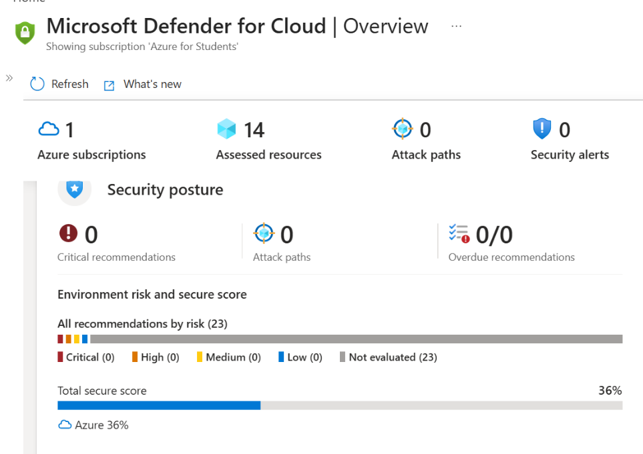
My current Secure Score is 36%, indicating a low level of security compliance within the Azure environment. This score reflects that several security recommendations have not yet been evaluated or implemented, leaving the system potentially exposed to risks. Improving this score requires addressing the outstanding recommendations and enabling security best practices.
- Which recommendations are active, and how they are prioritized
The environment currently has 23 recommendations, all of which are classified as “Not evaluated.” This indicates that Microsoft Defender for Cloud has identified potential security checks but has not yet assessed their risk levels. Normally, recommendations are prioritised into critical, high, medium, and low categories based on the potential impact and likelihood of exploitation, with critical issues requiring immediate attention.
- The nature and risk of your top three recommendations
Your evidence should clearly show the state of your environment before any changes are made.

Think | Why does Defender for Cloud assign different severity levels to recommendations? What factors determine whether a recommendation is critical vs. medium?

Task 2 — Remediation (4 Marks)
Select and implement fixes for two specific categories of risk. You do not need to resolve every recommendation — focus on these two:

2a — Close Open Management Ports (2 Marks)
Open RDP (port 3389) and SSH (port 22) exposure to the public internet is a well-known attack vector. Identify whether your environment has this risk and address it through your NSG configuration.
Document the before and after state of the relevant NSG rule(s). Your evidence should make the change and its security impact clear.

Before
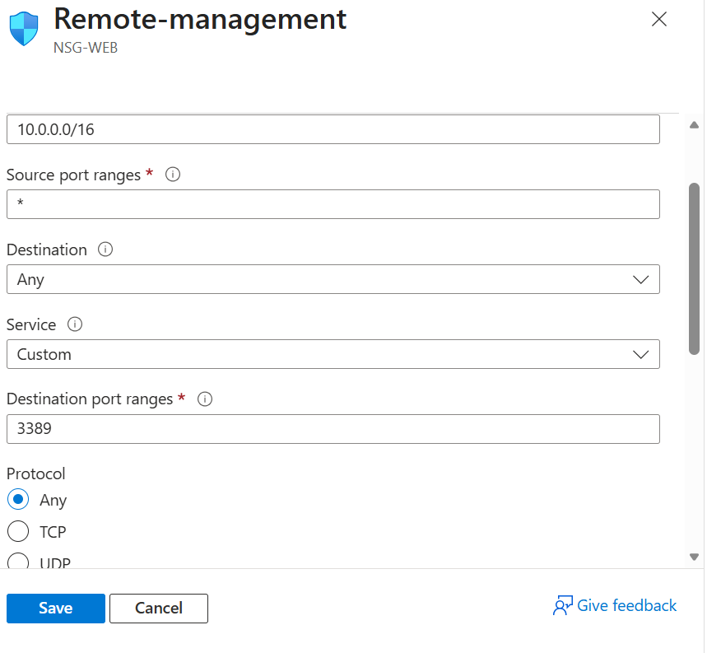
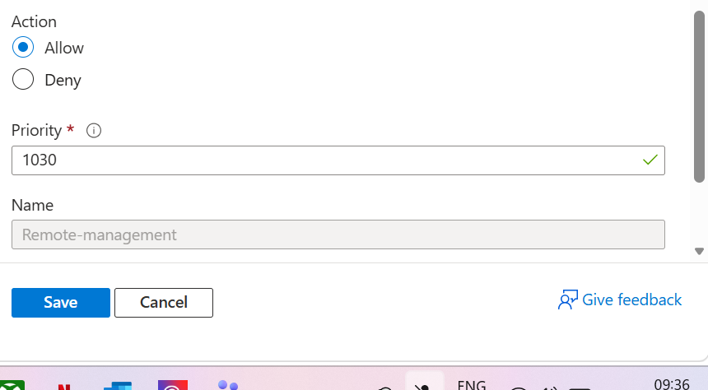

After
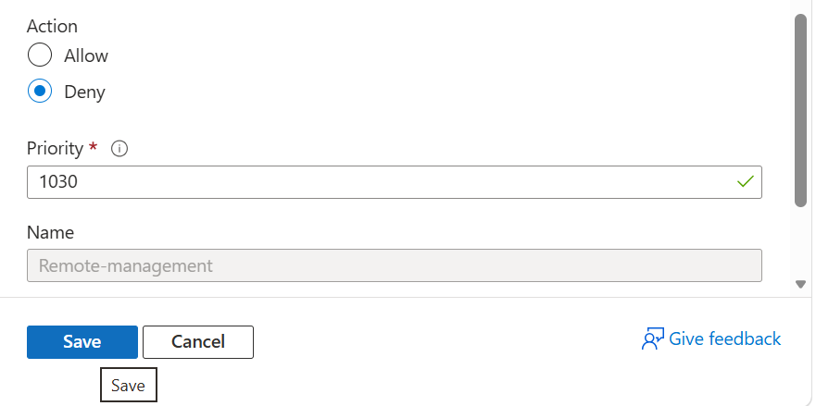

2b — Enable OS Updates (2 Marks)
Azure Update Manager (or the equivalent in your subscription tier) allows you to enforce automated update assessments and scheduled deployments. Locate the appropriate configuration and enable it for your VM.
Provide evidence that the configuration was applied — not just that the setting exists.
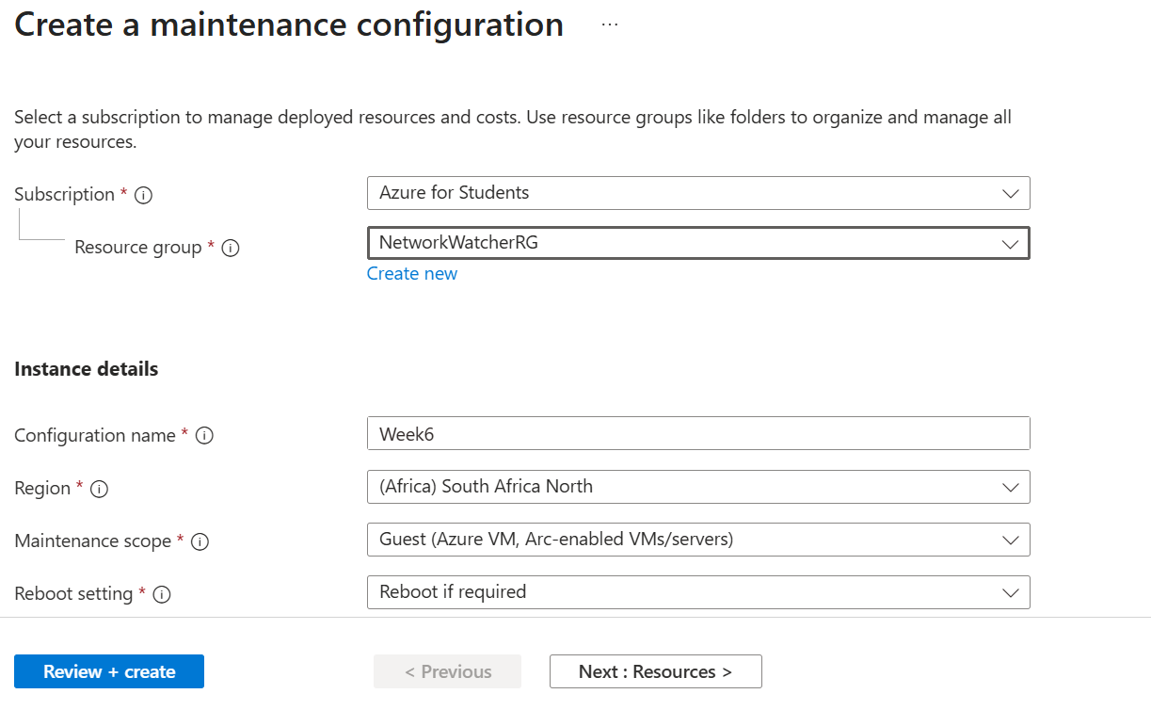
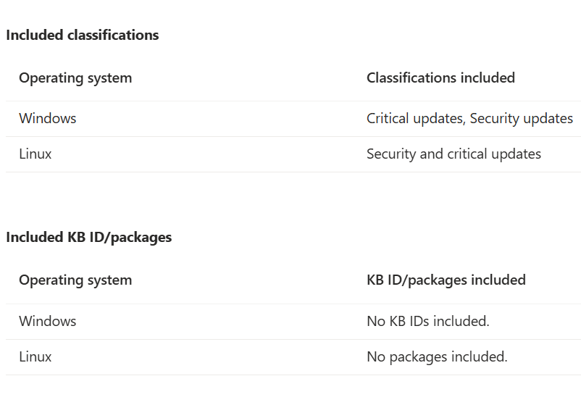
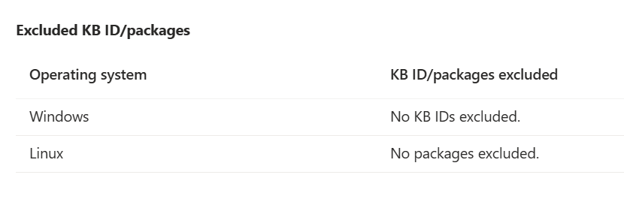

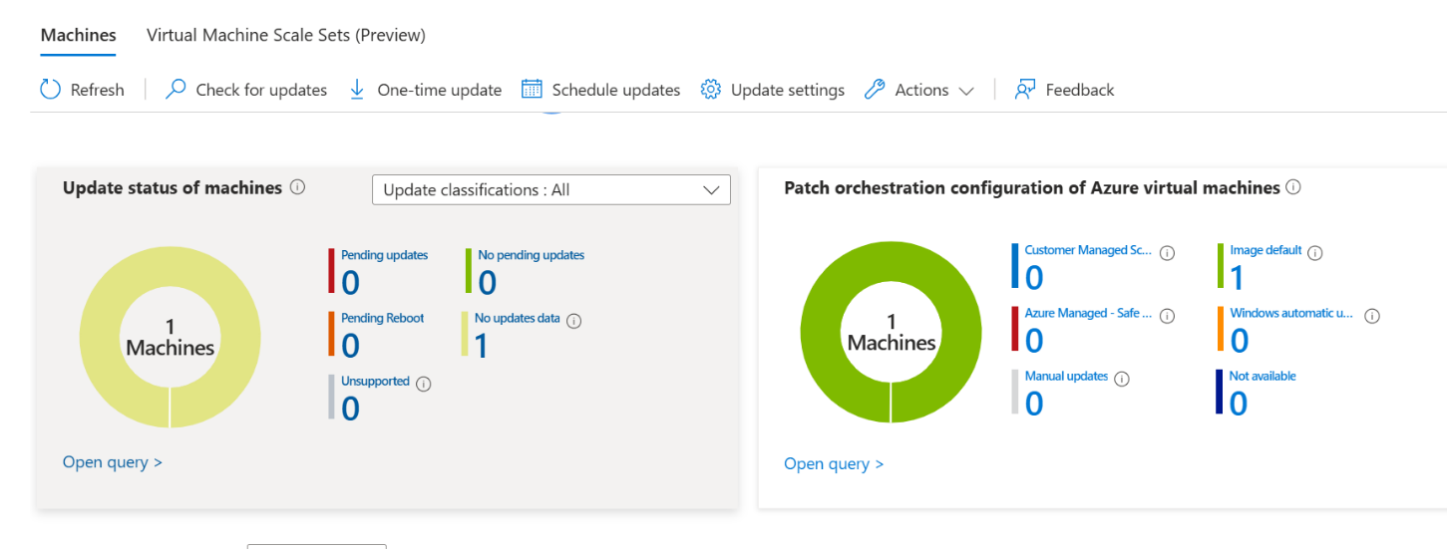
Note | If your subscription or VM configuration does not support a specific feature, document what you found and explain an alternative approach. Workarounds supported by reasoning are valid.

Task 3 — GitHub Documentation (3 Marks)
All evidence and analysis must be committed to your GitHub repository. A screenshot dump is not sufficient — your README should tell the story of what you found, what you changed, and why it matters.
Your repository should include:
- A structured README with clearly labelled before/after sections
- Screenshots embedded or linked with meaningful captions
- A brief written explanation for each remediation decision
- Visible commit history showing incremental progress (not a single bulk commit)

Think | How would you present this repository to a client or employer? Would someone who wasn't in this class understand what you did and why?

Submission
Submit the following via the LMS before the deadline:
- The public URL of your GitHub repository
- A brief summary (3–5 sentences) of the most significant security finding in your environment and the reasoning behind your remediation priority
Do not submit screenshots directly to the LMS. All visual evidence must live in your GitHub repository.

Mark Allocation
Task | Criteria | Marks
Defender for Cloud — Recommendations Review | Screenshot of Secure Score + list of top 3 active recommendations with descriptions | 3
Remediation — Close open ports | Evidence of NSG rule change + before/after screenshots | 2
Remediation — Enable OS updates | Screenshot of Update Manager configuration applied | 2
GitHub Documentation | README with structured before/after evidence and commit history visible | 3
TOTAL |  | 10

Academic Integrity
All submissions must reflect your own work. Identical repository structures, screenshots, or write-ups between students will be treated as a potential academic integrity violation. Your environment, your evidence, your words.

